Sample Individual Oral

Field of Inquiry: Art, Creativity and Imagination

Global Issue: The Need for Escapism

Works Discussed: John Keats’ poetry and Lucky Strike Cigarette Print Adverts



Click the icon to listen to the embedded recording

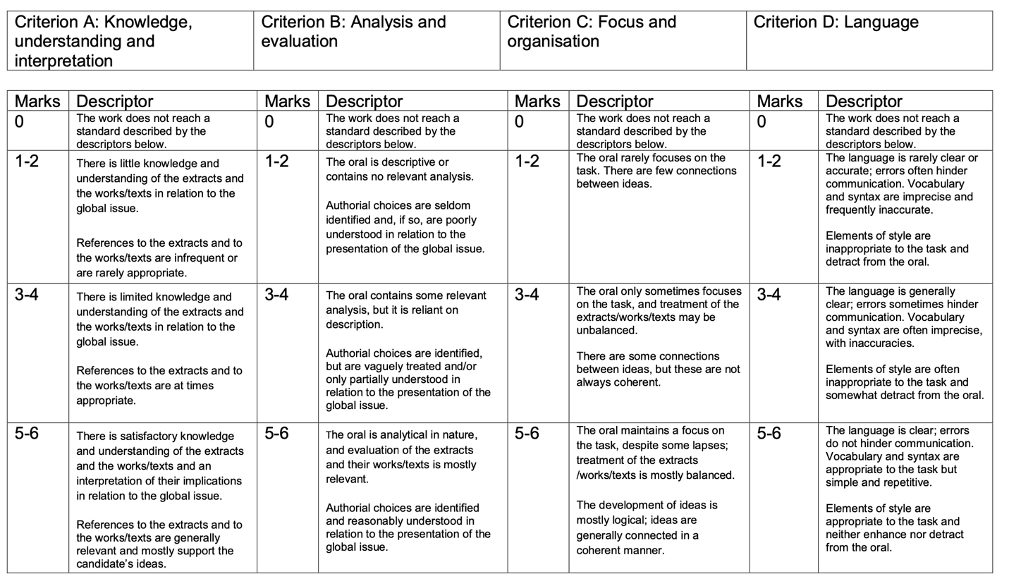
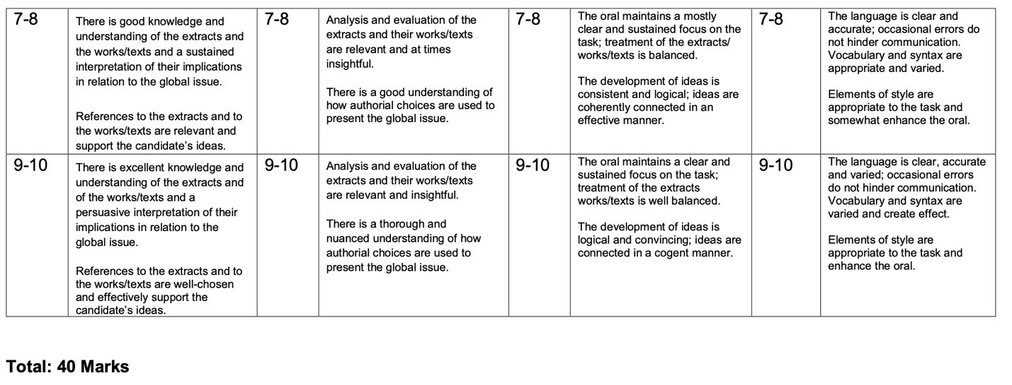

Extract from John Keats’ Ode to a Nightingale:

- My heart aches, and a drowsy numbness pains
- My sense, as though of hemlock I had drunk,
- Or emptied some dull opiate to the drains
- One minute past, and Lethe-wards had sunk:
- 'Tis not through envy of thy happy lot,
- But being too happy in thine happiness, —
- That thou, light-winged Dryad of the trees
- In some melodious plot
- Of beechen green, and shadows numberless,
- Singest of summer in full-throated ease.

- O, for a draught of vintage! that hath been
- Cool'd a long age in the deep-delved earth,
- Tasting of Flora and the country green,
- Dance, and Provençal song, and sunburnt mirth!
- O for a beaker full of the warm South,
- Full of the true, the blushful Hippocrene,
- With beaded bubbles winking at the brim,
- And purple-stained mouth;
- That I might drink, and leave the world unseen,
- And with thee fade away into the forest dim:

- Fade far away, dissolve, and quite forget
- What thou among the leaves hast never known,
- The weariness, the fever, and the fret
- Here, where men sit and hear each other groan;
- Where palsy shakes a few, sad, last gray hairs,
- Where youth grows pale, and spectre-thin, and dies;
- Where but to think is to be full of sorrow
- And leaden-eyed despairs,
- Where Beauty cannot keep her lustrous eyes,
- Or new Love pine at them beyond to-morrow.

- Away! away! for I will fly to thee,
- Not charioted by Bacchus and his pards,
- But on the viewless wings of Poesy,

Extract from Lucky Strike Print Ad Campaign:

