Sample Individual Oral

Field of Inquiry: Power, Politics and Justice

Global Issue: Child Exploitation

Works Discussed: Eric Ravelo’s Untouchables and The World’s Wife by Carol Ann Duffy



Click the icon to listen to the embedded recording

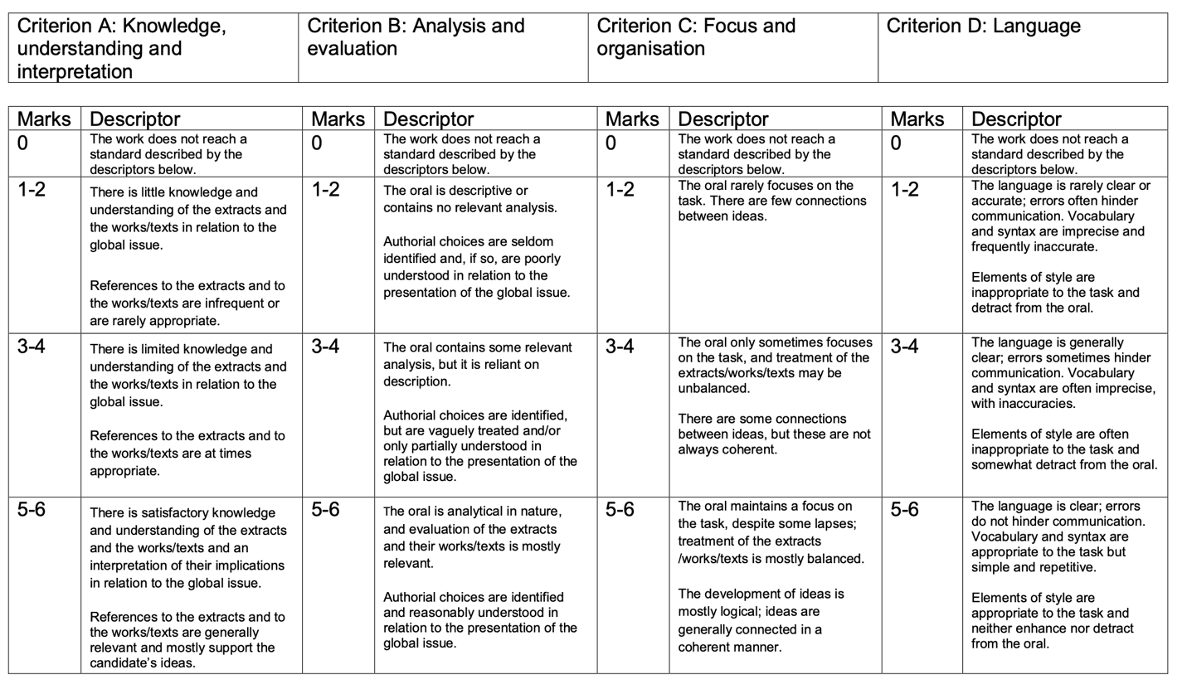
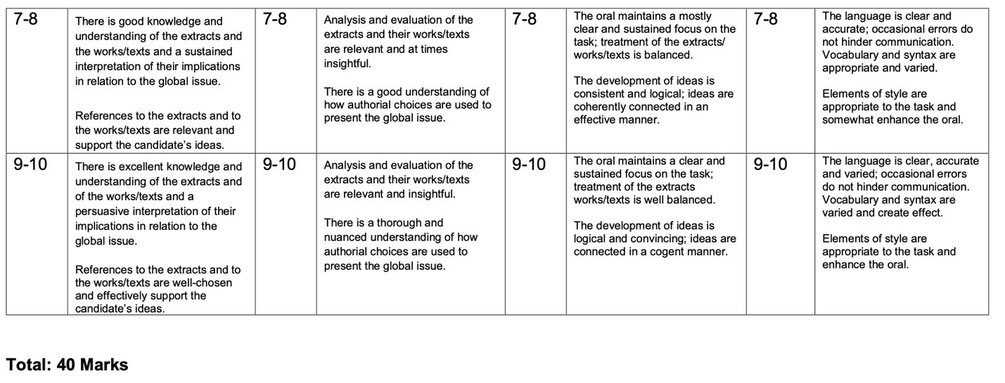

Extract from Eric Ravelo’s Untouchables:



Thailand

Extract from The World’s Wife:

