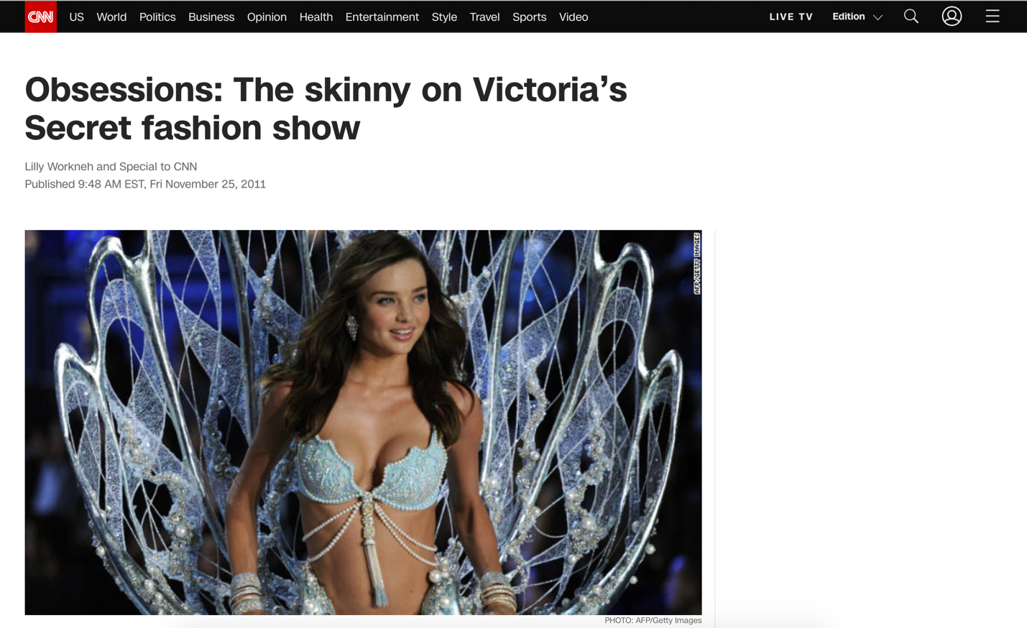
Model Miranda Kerr struts the catwalk at the 2011 Victoria's Secret fashion show in a $2.5 million bra.
PHOTO: AFP/Getty Images

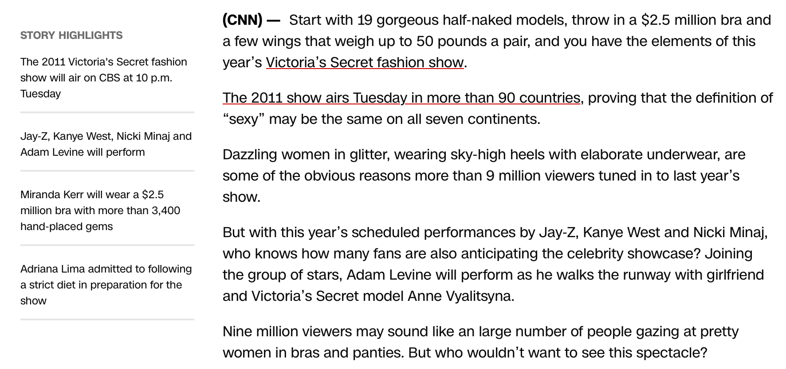

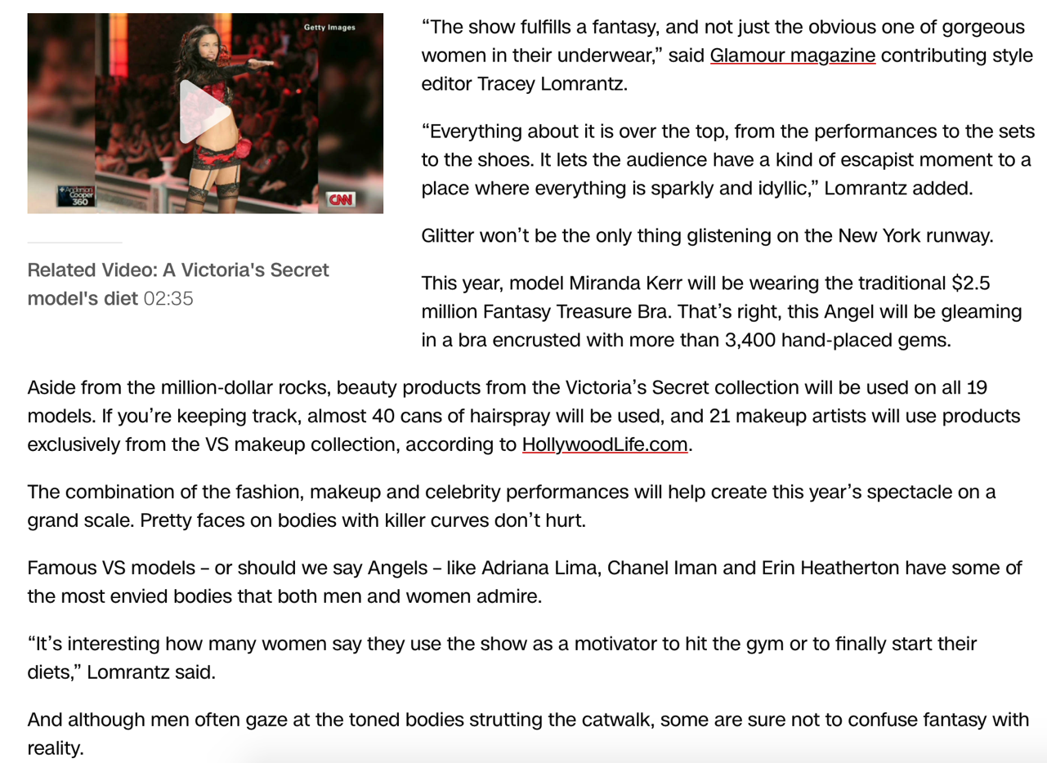
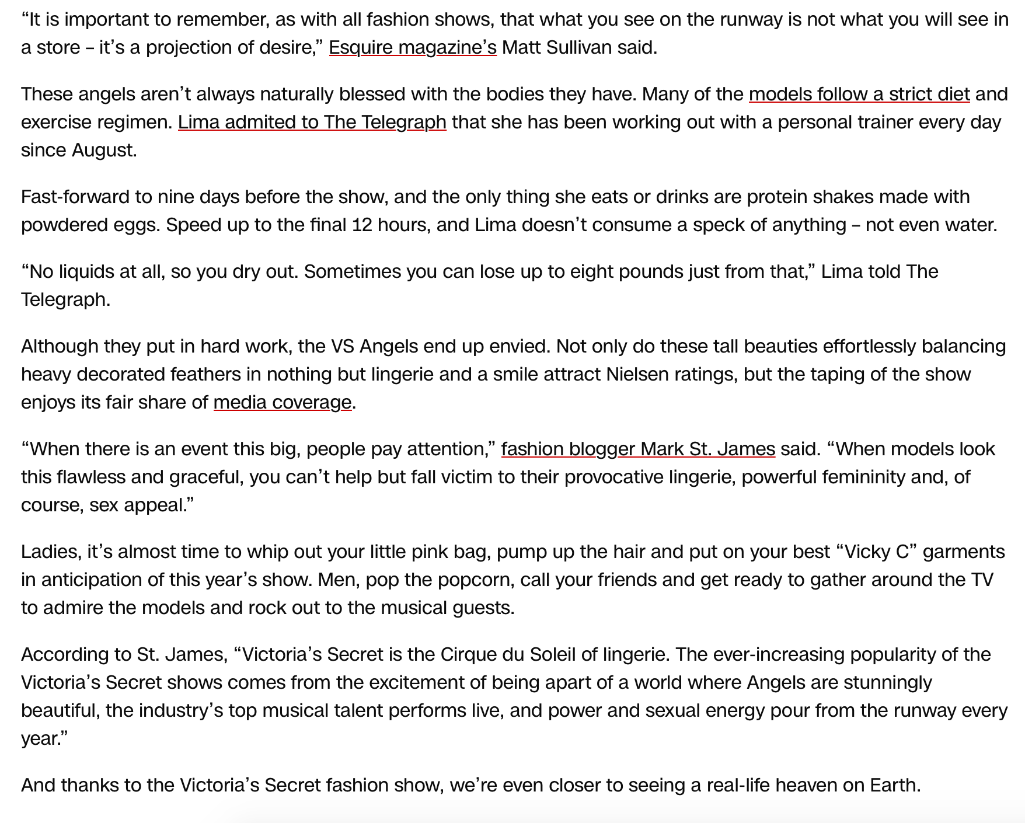

- How do formal features such as the headline, image and embedded interviews create effects in this article?

