Superman and George Bernard Shaw
Adapted from https://www.thoughtco.com/man-and-superman-themes-and-concepts-2713246

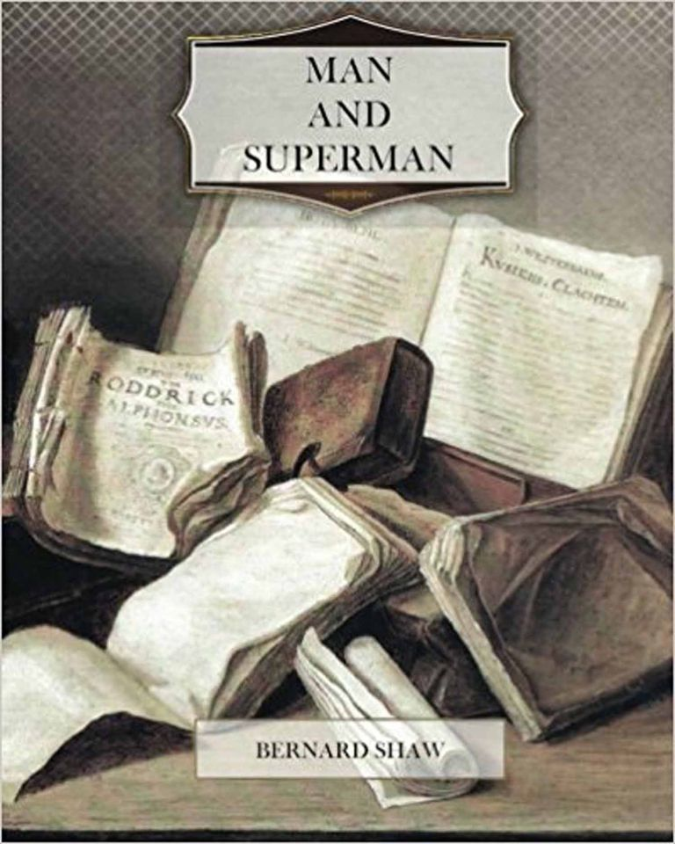
Ingrained within George Bernard Shaw’s humorous plays is a perplexing yet fascinating philosophy: the concept of ‘Superman.’
First of all, don’t get the philosophical idea of the ‘Superman’ mixed up with the comic book hero who flies around in blue tights and red shorts saving the world. The Superman we’re talking about is a philosophical concept which Shaw imbued into the characters of his plays. The features of this archetype are:
- Superior intellect
- Cunning and intuition
- Ability to defy obsolete moral codes
- Self-defined virtues
Shaw believed that certain figures in history displayed some of these Superman traits: Julius Caesar; Napoleon Bonaparte; Oliver Cromwell. Each person is a highly influential and capable leader. However, each of these historical figure’s stories ended in failure. Shaw argues that the fate of each of these ‘supermen’ was caused by the mediocrity of society. Because most people in society are unexceptional, the few Supermen who occasionally appear face a nearly impossible challenge. They must either conflict with and subdue mediocrity or raise mediocrity up to the same level – in other words, create their own ‘Supermen.’
Shaw states that the concept of the Superman has been around for millennia, ever since the myth of Prometheus. He was the titan who defied Zeus and the other Olympian gods by bringing fire to mankind, thereby empowering man with a gift meant only for deities. Any character or historical figure who, like Prometheus, endeavours to create his own destiny, empower others and strive towards greatness be considered a ‘superman’ of sorts.
The modern concept of ‘Superman’ is usually attributed to Friedrich Nietzsche. In his 1883 book Thus Spake Zarathustra, Nietzsche provides a vague description of an “Ubermensch”—loosely translated into Overman or Superman. He states, “man is something which ought to be overcome,” and by this, he seems to mean that people ought to strive against their weak and base selves in order to ‘evolve’ – spiritually, intellectually, psychologically and socially.
Because the definition is rather unspecified, some have interpreted a ‘superman’ to be someone who is simply superior in strength and mental ability. But what really makes the Ubermensch out of the ordinary is his unique moral code. Nietzsche stated that "God is dead" and was not guided by religion, which he believed was a fallacy. He believed that people must find their own way in the modern world and discard the mistaken beliefs of the past or outdated moral codes of behaviour.
Through adapting Nietzsche’s ideas, Shaw wrote plays in which he suggested the Superman could benefit society. One of his plays was even called ‘Man and Superman’, in which the lead character, Jack Tanner, wrote a political manifesto based on Nietzche’s ideas.
In Pygmalion, Henry Higgins represents the ‘Superman’. Where most citizens take comfort in ‘normal’ traditions and codes of behaviour, Higgins does not follow the crowd. He challenges age-old institutions such as marriage and manners. Some ‘mainstream’ thinkers in the play find the things his character says and does hard to accept.
Shaw was a member of the Fabian Society, a socialist group who advocated gradual change from within the British government. Shaw believed that the upper classes (landlords and aristocrats) had an unfair advantage over the common man. He felt that class prejudices narrowed the range of human possibility, because people are only likely to marry within their own class. He felt that it prevented many people of different classes and creeds from copulating with one another. Keep in mind, he wrote this in the early 1900s when pre-marital sex was scandalous, so his ideas in this regard were also quite extraordinary! He advocated a socialist model of society that would provide an equal playing field, minimizing class prejudice and speeding the development of a society of Supermen. Basically, he contends that most people get married and have children for the wrong reasons: they should be partnering with a mate that exhibits physical and mental qualities that are likely to produce beneficial traits in the pair’s offspring, rather than be married for reasons of class.
(However, in his own life, Shaw gave up his status as an eligible bachelor and married Charlotte Payne-Townshend, with whom he spent the next forty-five years. So, perhaps revolutionary life is a pleasant pursuit for those with exceptional qualities - but it is difficult for non-Supermen to resist the pull of traditional values.)
At the start of the play, Henry Higgins certainly demonstrates the traits of the ‘Superman’. Yet, it’s Liza Doolittle, the woman who asks to be transformed so she can work in a flower-shop that demonstrates the ‘Superman ideal’ — she’s the one who knows what she wants and has to follow her own moral code to achieve her desires.
Maybe she’s the Superwoman?

