
Is Zwarte Piet racism?
A debate on a holiday tradition exposes racial attitudes
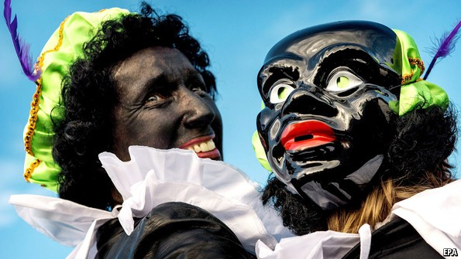
EVERY year on December 5th and 6th, tens of thousands of Dutch people paint their faces black, don Renaissance-style jerkins and pantaloons, and assume the persona of Zwarte Piet ("Black Pete"). The comical character plays a vital part in the celebration of the feast day of St Nicholas, known as Sinterklaas, which overshadows Christmas as the most important children’s holiday. According to a custom standardised in the late 1800s, Sinterklaas arrives on a steamboat from Spain, accompanied by a team of his black-faced servants, who distribute presents and ginger biscuits to good children while threatening to scoop up naughty ones in a sack and carry them back to Spain to pick oranges.
With his fantastical role and antique costume, Zwarte Piet seems disconnected from modern racial stereotypes. He made it through the Netherlands’ politically correct 1990s without raising many eyebrows. Yet in recent years Dutch citizens of Caribbean ancestry have begun protesting the portrayal of St Nicholas’s sidekick as a racist caricature. In the increasingly polarised political climate in the Netherlands, the custom was a tinderbox waiting for a match. In October the debate exploded, polarising cultural life and dragging in celebrities, politicians, and even the UN.
The man who lit the tinderbox is Quinsy Gario, a Curaçao-born Dutch performance artist, who began protesting in 2011 when he attended a Sinterklaas parade wearing a T-shirt reading “Zwarte Piet is racism” and was arrested. In early October Mr Gario appeared on the Netherlands’ most popular television talk-show to make his case again. The following week, the mayor of Amsterdam met with dozens of residents who had submitted a complaint asking that Zwarte Piet be removed from the city’s Sinterklaas parade.
Most white Dutch reacted angrily to accusations that the tradition is racist. On social media, many repeated a long-standing claim that Zwarte Piet just appears black because of soot from the chimneys he climbs down to deliver presents. The right-leaning Telegraaf, the country’s largest newspaper, ran articles claiming anti-Piet voices were troublemakers who did not represent black people in the Netherlands. A “Pietition” page on Facebook backing Zwarte Piet gathered over 2m likes within days, a staggering response in a country of 17m.
Many Dutch who have come out against Zwarte Piet have been hounded by the traditionalists. One group in the country’s north who had planned to paint themselves as multicoloured “rainbow-Piets” had to give up after receiving death threats. Anouk, the Dutch representative at this year’s Eurovision contest, was attacked with racial epithets for her opposition to the custom. When a Jamaican researcher for a UN cultural panel said she thought Zwarte Piet was racist, she was overwhelmed with racially offensive e-mails. Geert Wilders, the anti-immigrant populist whose Party for Freedom is currently on top of the Dutch polls, tweeted that he would rather eliminate the UN than Zwarte Piet. A pro-Piet protest in The Hague turned sour when a dark-skinned woman was surrounded by an angry mob and had to be rescued by police.
Mark Rutte, the prime minister from the centre-right Liberal Party, commented simply that “Black Pete is black”. The head of his centre-left coalition partners, Diederik Samsom, belittled the argument as an affair for people with too much time on their hands. But while the symbolism of a children’s holiday may be of limited consequence, the contemptible racial attitudes it has exposed are not. This month’s conflict has changed Zwarte Piet. For many, even if a year ago he was not a symbol of Dutch racism, he is now.

Cultural learnings of Kazakhstan
If you can't beat Borat, then borrow his brand

WHY should anyone care about the Kazaks? Or should that be Kazakhs? It is hard to get excited about a country that can't decide even how to spell its own name. So please greet Borat, the latest fictional creation of a British comic impersonator, Sacha Baron Cohen. Borat is the lecherous, clownish envoy of a culture steeped in racism, sexism, poverty and brutality. The film of his visit to America is extremely funny. So hearty applause all round. And tell those Kazzies not to be so prickly.
That, broadly, is the Western reaction to Kazak protests about Borat. The film may be a ludicrous and offensive caricature. But so what? Nobody's heard of you anyway. So stop complaining.
But it is not quite so simple. Kazakhstan is the size of western Europe. The country matters hugely for the energy security of the continent. It is doing rather well economically, rather less well politically (though nowhere near as badly as dictatorial Uzbekistan and lunatic Turkmenistan). Given Kazakhstan's importance, Western ignorance of it is striking. Ten years ago your correspondent was talking to an academic, now a high-ranking official in the Bush administration, who was under the confident but mistaken impression that Kazakhstan was not a Muslim country, because, as its name indicated, it was “where the Cossacks lived”. Not much has changed.
It is a fair bet that Mr Baron Cohen would not have chosen as Borat's homeland a country that featured more prominently in the Western worldview—such as Turkey, for example. Most people would know that Turks did not hunt Gypsies or drink fermented horse urine, some of the pastimes which Mr Baron Cohen attributes to Kazakhstan. Countries such as Turkey are, moreover, good at defending themselves vehemently when criticised.
Foreign satire used to be so much better. The superb “USSR: From an Original Idea by Karl Marx”, by Marc Polonsky and Russell Taylor, was a cult classic of the cold war; so was Malcolm Bradbury's spoof guidebook, “Why Come to Slaka?”. It seems a bit odd that the best creative minds of the West are still flogging the tired old gag that the ex-captive nations are amusingly obscure and backward. The slick, self-satisfied Anglo-American creative elite is so devastatingly witty at other people's expense, but ultra-prickly when it comes to its own dignity.
It would be nice to have some comedy dealing with real themes from the post-communist world: Could not a latter-day Charlie Chaplin satirise the pomposity and vulgarity of Putin's Kremlin? There is plenty for thriller-writers to chew on, too: the combination of cynicism, sleaze and geopolitical arm-wrestling across the ex-communist world cries out for a return there by Le Carré.
Kazakhstan is an easy target for lazy wit. There is no powerful Kazak diaspora to threaten a boycott. Official Kazak efforts to defend the country have been ludicrously counterproductive: the dodgy deletion of borat.kz; an expensive special advertising supplement in the New York Times; part-plaintive, part-pompous letters from ambassadors; empty threats of legal action (to which Mr Baron Cohen has responded by issuing a statement from Borat praising the Kazak decision to “sue the Jew Cohen”).
The only constructive response is to say that all publicity is good publicity. Millions of filmgoers around the world will now have a rough idea that Kazakhstan exists, and they will probably reckon that it cannot really be as benighted as Borat makes out. The Kazak government—remembering that the real victim of Mr Baron Cohen's parody is not their country, but America—should have the nerve to make Borat the centrepiece of the next national branding campaign, under the slogan “Kazakhstan: less funny than the film—but a lot more fun.”

Misrepresentations
“Artistic Encounters with Indigenous America” is timely and troubling
The exhibition lays bare a long history of racist stereotypes, attitudes and policies
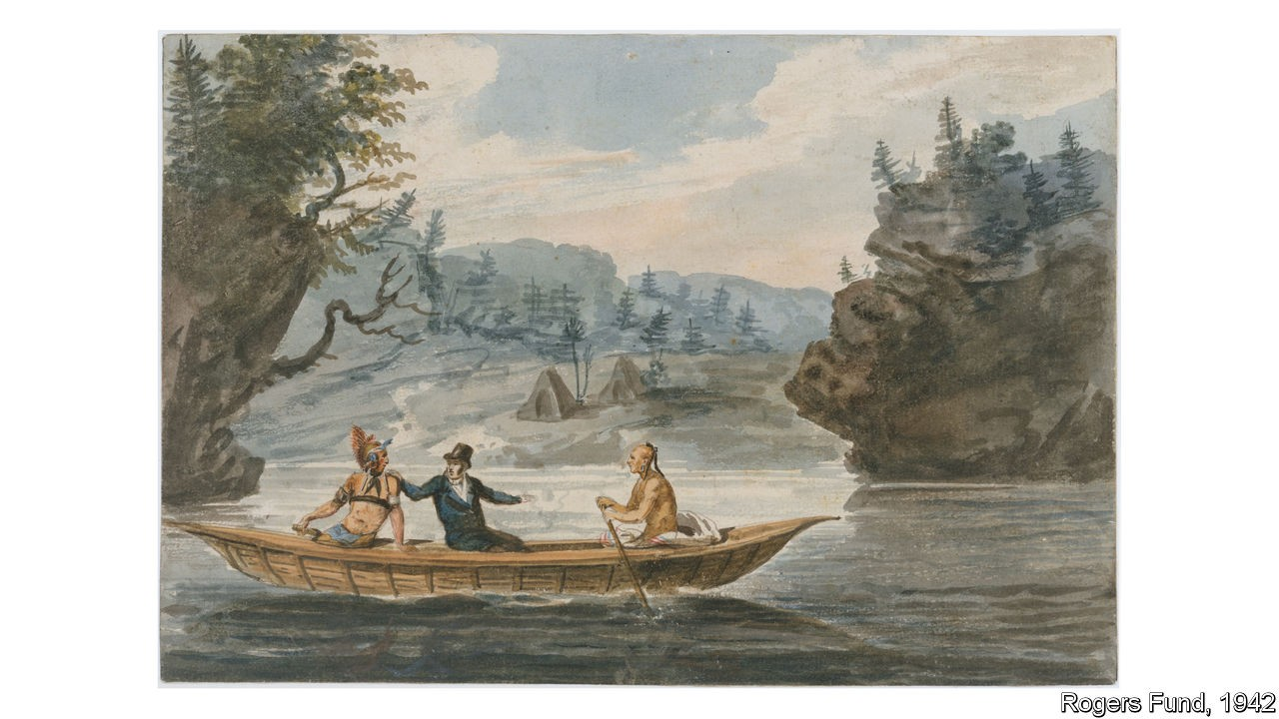
BETWEEN 1811 and 1813 Pavel Petrovich Svin’in, a Russian diplomat, travelled across eastern America gathering stories and images. The resulting travelogue, “A Picturesque Voyage in North America” (1815), purported to reveal to curious foreigners how Native Americans lived; in truth, Svin’in and his illustrators never witnessed many of the scenes the book depicted. Instead, they drew upon pernicious cultural stereotypes, creating sensational paintings that would stimulate the imaginations of readers abroad. Svin’in’s watercolour of a European man in a top hat grappling with two barely clothed Native American men in a canoe (pictured) powerfully encapsulates the offensive misconception—held by Euro-American societies for centuries—that indigenous American cultures are uncivilised and uncouth.
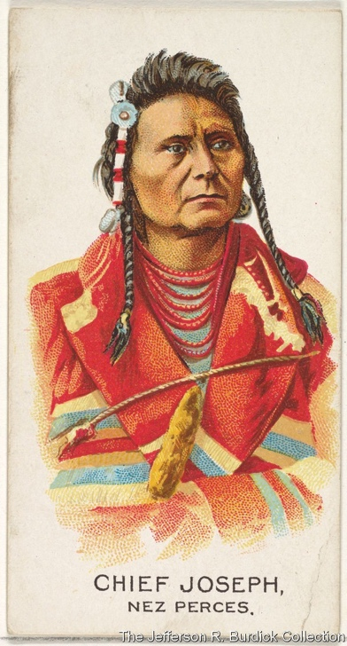
“Artistic Encounters with Indigenous America”, a small but thought-provoking exhibition at the Metropolitan Museum of Art in New York, explores how European artists have depicted Native Americans over the past five centuries. The exhibition begins with efforts to sell the fantasy of America in the 17th century by emphasising the “exotic” qualities of indigenous groups. The “Indian princess”—a beautiful woman covered in animal skins and feathers—was an especially popular trope, seen to embody the independent spirit of the young United States. “An Emblem of America” (1801), a print, depicts a woman wearing a leopard skin in a lushly vegetated landscape; the title links the supposedly wild sexuality of indigenous women with the fertility of American soil. By the turn of the 19th century, even as the national government refused to accept Native claims to land and resources, the depiction of America as an “Indian princess” recurred in visual mythology.

The exhibition also features images by artists convinced by the notion of a “doomed race”. Their subjects were usually tribal chiefs, such as Chief Joseph of the Nez Perce, who campaigned for the return of ancestral lands in the late 19th century. These tragic, romanticised portraits appeared in both ethnographic studies and in advertisements, contributing to the idea of the “noble savage”. On display are collectible Allen & Ginter cigarette packages (1888), showing stoic indigenous chiefs in ceremonial clothing. These promoted a Native American crop—tobacco—which many groups could no longer cultivate due to their forced displacement.
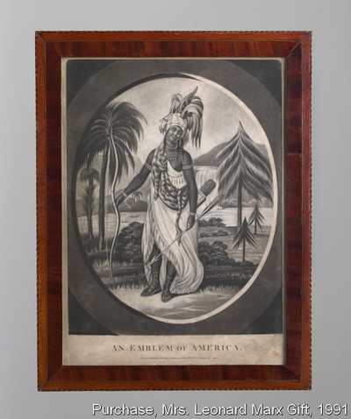
By the early 20th century Euro-American artists began to create more humanised portraits. Some members of the Taos creative colony, a group of artists and writers, journeyed around New Mexico and observed Pueblo culture. They recorded scenes of women working on pottery and of local celebrations, which began to be heavily frequented by tourists from the 1920s onwards. While the colony's work resulted in more naturalistic portrayals and an appreciation of customs, it also contravened the wishes of communities who did not want to be photographed or sketched. Artists such as Gene Kloss and John Marin depicted Pueblo ceremonial dances from memory instead.
By juxtaposing troubling images with enlightening interpretative texts from the curators and Wendy Red Star, an indigenous artist, the exhibition offers an arresting examination of non-Native depictions of Native cultures. However, the exhibition’s impact is dulled by its location within the museum. Although it is sensibly placed within the airy American Wing, the exhibition occupies an inconvenient, hard-to-find location: a small mezzanine in the farthest corner of this large building, accessible only through the open archives or via an elevator. A show about a marginalised group exists in the institution’s margins.
This exhibition is important viewing, so it is a shame that so few will be able to find it. Harmful stereotypes and gross simplifications about indigenous American culture persist. President Donald Trump has frequently taunted Elizabeth Warren, a senator, about her avowed Native American ancestry with the name “Pocahontas”—considered a racial slur by many indigenous groups. On January 18th a video from the March for Life in Washington, DC, went viral, showing Nathan Phillips, an Omaha tribal elder, being intimidated by a male teenager; the boy, wearing a “Make America Great Again” cap, was encouraged by his friends, who shouted disparaging remarks about Native Americans. It is clear that the attitudes laid bare in “Artistic Encounters with Indigenous America” are not yet consigned to history.

