Euphemisms

Making murder respectable

Phoney politeness and muddled messages: a guide to euphemisms
Source: http://www.economist.com/node/21541767
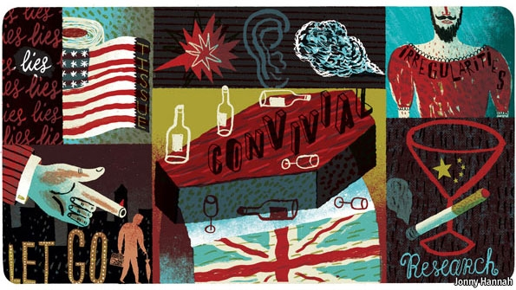
SHORT sharp terms make big points clear. But people often prefer to soften their speech with euphemism: a mixture of abstraction, metaphor, slang and understatement that offers protection against the offensive, harsh or blunt. In 1945, in one of history's greatest euphemisms, Emperor Hirohito informed his subjects of their country's unconditional surrender (after two atomic bombs, the loss of 3m people and with invasion looming) with the words, “The war situation has developed not necessarily to Japan's advantage.”
Euphemisms range promiscuously, from diplomacy (“the minister is indisposed”, meaning he won't be coming) to the bedroom (a grande horizontale in France is a notable courtesan). But it is possible to attempt a euphemistic taxonomy. One way to categorise them is ethical. In “Politics and the English Language”, George Orwell wrote that obfuscatory political language is designed “to make lies sound truthful and murder respectable”. Some euphemisms do distort and mislead; but some are motivated by kindness.
Another way to typify them is by theme. A third—and a useful way to begin—is by nationality. A euphemism is a kind of lie, and the lies peoples and countries tell themselves are revealing.
American euphemisms are in a class of their own, principally because they seem to involve words that few would find offensive to start with, replaced by phrases that are meaninglessly ambiguous: bathroom tissue for lavatory paper, dental appliances for false teeth, previously owned rather than used, wellness centres for hospitals, which conduct procedures not operations. As the late George Carlin, an American comedian, noted, people used to get old and die. Now they become first preelderly, then senior citizens and pass away in a terminal episode or (if doctors botch their treatment) after a therapeutic misadventure. These bespeak a national yearning for perfection, bodily and otherwise.
Sensitive China, perfidious Albion
Some Chinese euphemisms also stem from squeamishness. Rather than inquire about a patient's sex life, doctors may ask if you have much time for fang shi (room business). Online sites sell qingqu yongpin, literally “interesting love products”.
But Chinese circumlocution is often a form of polite opacity. Chinese people don't like being too direct in turning down invitations or (as many journalists find) requests for interviews. So they will frequently reply that something is bu fangbian (not convenient). This does not mean reapply in a few weeks' time. It means they don't want to do it, ever. If they don't want to tell you what is going on they will say vaguely they are bu qingchu: literally “I'm not clear.”
One feature of Chinese euphemisms comes from the tonal nature of the language. Yan is slang for cigarettes; jiu means alcohol. But, with different tones, the two syllables together can also mean “to research”. So a corrupt official being asked to do something might suggest, “Let's research (yanjiu) this issue together”, by which he would probably mean, “Give me some cigarettes and some alcohol and I'll make it happen.”
The British are probably the world champions of euphemism. The best of these are widely understood (at least among natives), creating a pleasant sense of complicity between the euphemist and his audience. British newspaper obituaries are a rich seam: nobody likes to speak ill of the dead, yet many enjoy a hint of the truth about the person who has “passed away”. A drunkard will be described as “convivial” or “cheery”. Unbearably garrulous is “sociable” or the dread “ebullient”; “lively wit” means a penchant for telling cruel and unfunny stories. “Austere” and “reserved” mean joyless and depressed. Someone with a foul temper “did not suffer fools gladly”. The priapic will have “enjoyed female company”; nymphomania is “notable vivacity”. Uncontrollable appetites of all sorts may earn the ultimate accolade: “He lived life to the full.”
Such euphemisms are a pleasant echo of an age when private lives enjoyed a degree of protective discretion that now seems unimaginable in Britain. That left room for “a confirmed bachelor” (a homosexual) or someone “burdened by occasional irregularities in his private life” (leaving the reader guessing whether the problem was indecent exposure, adultery or cross-dressing).
Writing about dead people is a question only of taste, because they can't sue. Describing the living (especially in libel-happy jurisdictions such as England) requires prudence. “Thirsty” applied to a British public figure usually means heavy drinking; “tired and emotional” (a term that has moved from the pages of Private Eye, a satirical magazine, into general parlance) means visibly drunk. “Hands-on mentoring” of a junior colleague can be code for an affair, hopefully not coupled with a “volatile” personality, which means terrifying eruptions of temper. References to “rumbustious” business practices or “controversial”, “murky” and “questionable” conduct usually mean the journalist believes something illegal is going on, but couldn't stand it up in court if sued.
In the upper reaches of the British establishment, euphemism is a fine art, one that new arrivals need to master quickly. “Other Whitehall agencies” or “our friends over the river” means the intelligence services (American spooks often say they “work for the government”). A civil servant warning a minister that a decision would be “courageous” is saying that it will be career-cripplingly unpopular. “Adventurous” is even worse: it means mad and unworkable. A “frank discussion” is a row, while a “robust exchange of views” is a full-scale shouting match. (These kind of euphemisms are also common in Japanese, where the reply maemuki ni kento sasete itadakimasu—I will examine it in a forward-looking manner—means something on the lines of “This idea is so stupid that I am cross you are even asking me and will certainly ignore it.”)
Euphemism is so ingrained in British speech that foreigners, even those who speak fluent English, may miss the signals contained in such bland remarks as “incidentally” (which means, “I am now telling you the purpose of this discussion”); and “with the greatest respect” (“You are mistaken and silly”). This sort of code allows the speaker to express anger, contempt or outright disagreement without making the emotional investment needed to do so directly. Some find that cowardly.
Boardroom, bathroom, bedroom
A thematic taxonomy of euphemism should have a category devoted to commerce. Business euphemisms are epitomised by the lexicon of property salesmen. A “bijou” residence is tiny (it may also be “charming”, “cosy” or “compact”). A “vibrant” neighbourhood is deafeningly noisy; if it is “up and coming” it is terrifyingly crime-ridden, whereas a “stone's throw from” means in reach of a powerful catapult. Conversely, “convenient for” means “unpleasantly close to”. “Characterful” means the previous owner was mad or squalid. “Scope for renovation” means decrepit; “would suit an enthusiast” means a ruin fit only for a madman.
But the richest categories would centre on cross-cultural taboos such as death and bodily functions. The latter seem to embarrass Americans especially: one can ask for the “loo” in a British restaurant without budging an eyebrow; don't try that in New York. Lavatory and toilet were once euphemisms themselves; they in turn were replaced by water closet (WC) and the absurd “rest room”. British English encourages lively scatological synonyms: foreigners told that someone is “taking a slash” or “on the bog” may be mystified.
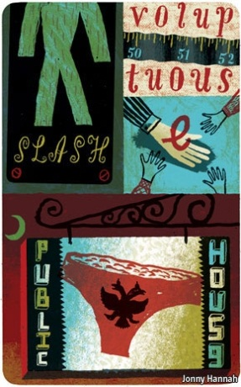
Sex outstrips even excretion as a source of euphemism. The Bible is full of them: “foot” for penis, “know” for intercourse, with “other flesh” if transgressive. Masturbation was self-abuse or the sin of Onan to the Victorians; oral sex is “playing the bamboo flute” in Japanese. A prostitute accosting a client on the streets of Cairo will ask Fi hadd bitaghsal hudoumak ? (Literally, “Do you have someone to wash your clothes?”)
Even the most straight-talking obfuscate that line of work. Swedes, like many others, refer to världens äldsta yrke (the world's oldest profession). A brothel in Russian is a publichny dom—literally a “public house”, which causes problems when British visitors with rudimentary Russian try to explain the delights of their village hostelry. In China many hair salons, massage parlours and karaoke bars double as brothels. Hence anmo (massage), falang (hair salon) or a zuyu zhongxin (foot-massage parlour) can lead to knowing nods and winks. For obscure reasons, Germans call the same institution a Puff. In Japan, such places are called sopurando, (a corrupted version of “soapland”) or a pin-saro (pink salon).
Euphemisms for the act itself may be prim (carnal knowledge), poetic (make love) or crude (shagging). Over time such expressions lose their suggestive power and may even become off limits themselves. To engage in sexual intercourse in German is b umsen (to thump), along the lines of the English “bonk”. To masturbate is wichsen (to polish). In both cases the slang sexual connotation has overtaken the original one.
Personal ads provide an entire subgenre of euphemism. “Cuddly” means “fat”. “Romantic” means needy and clingy. “Old-fashioned” means inconsiderate sex (if male) or infrequent (for females). “Outgoing and fun-loving” mean annoyingly talkative, promiscuous or both. “Open-minded” means desperate.
Little white lies
Orwell was right: euphemisms can be sneaky and coercive. They cloak a decision's unpleasant results, as in “let go” for “fire”, or “right-sizing” for “mass sackings”. They make consequences sound less horrid—as, chillingly, in “collateral damage” for “dead civilians”.
Such jargony, polysyllabic euphemisms, often using long Latinate words instead of short Anglo-Saxon ones, can quickly become an argot used by slippery-tongued, well-educated insiders to defend their privileges. With luck, the real word may fall into disuse and the humble outsider will feel intimidated by the floppy, opaque language that masks wrongdoing or shortcoming. How do you begin to complain if you don't know the lingo?
Politically correct euphemisms are among the most pernicious. Good and bad become “appropriate” or “inappropriate”. A ghastly problem becomes a less alarming “challenging issue”. Spending is investment; cuts are savings. “Affected by material error” (in European Union parlance) means money stolen from the budget.
But euphemisms can also be benign, even necessary. Sometimes the need to prevent hurt feelings justifiably takes precedence over clarity. Saying that dim or disruptive children have “special needs”, or that they exhibit “challenging behaviour”, does not make them easier to teach—but it may prevent them being teased or disheartened. “Frail” (of an old person) is nicer than doddery or senile. Euphemisms may be a species of lie, but some of them are white.
A culture without euphemism would be more honest, but rougher. Here's a New Year's resolution: scrub your conversation of euphemism for a day. The results will startle you.
From the print edition: International

